

TECHNICAL UNIVERSITY OF KENYA
FACULTY OF APPLIED SCIENCES AND TECHNOLOGY
SCHOOL OF COMPUTING & INFORMATION TECHNOLOGY
END OF SEMESTER MAY2017 EXAMINATION SERIES
FIRST SEMESTER EXAMINATIONS 2016/2017
THIRD YEAR EXAMINATIONS FOR THE DEGREE OF
BACHELOR OF TECHNOLOGY IN COMPUTER TECHNOLOGY
BACHELOR OF TECHNOLOGY IN INFORMATION TECHNOLOGY
BACHELOR OF TECHNOLOGY IN COMMUNICATION AND COMPUTER NETWORKS
ECSI 3104/ECII 3104/ECCI 3104:DATA STRUCTURES, ANALYSIS AND DESIGN OF ALGORITHMS
TIME: 2 Hours MAY 2017
Instructions to candidates:
This paper consists of FIVE Questions.
Answer Question ONE [30 Marks] and any other TWO Questions [20 Marks Each].
Mobile phones and any written materials are prohibited in the examination room.
Programmable calculators are prohibited
Write your college number on the answer sheet.
This paper consists of 3 printed pages
Candidates should check the question paper to ascertain that all the pages are printed as indicated and that no questions are missing.

@May 2017 The Technical University of Kenya

Question ONE [30 Marks] [Compulsory]
- Explain the following terms:
- Algorithm
- Sort in place
- ith order statistic
- Comparison based sorting algorithm 6 Marks
- Outline the difference between the following as used in analysis of algorithm
- Data structure and File structure
- Data type and Data item
- A string and an array 6 Marks

- Briefly outline why asymptotic notation is used in the analysis of the performance of algorithms 3 Marks
- Define what is meant by a loop invariant 3 Marks
- Below is the pseudocode for Merge Sort:
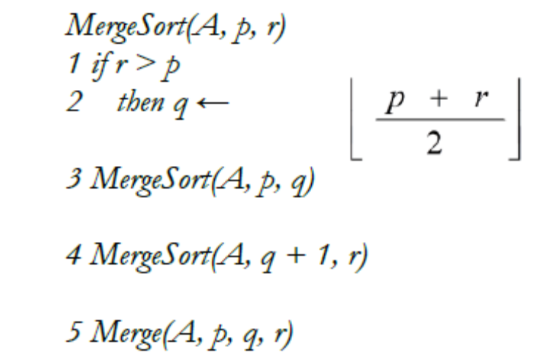

Use the above pseudocode to explain:-
- term recurrence
- why Merge sort is classified under the Divide and Conquer paradigm; identify the ‘Divide’ and ‘Conquer’ components in the above pseudocode 6 Marks

- Describe three features of an algorithm 6 Marks

Question TWO [20 Marks]
- Define Abstract data type (ADT), and outline some four examples of ADT 5 Marks
- If an array holds integers, each of which is four bytes long, how many bytes from the base location of the array is the location of the fifth element 6 Marks

- The complexity of Bubble sort and Selection sort is exactly the same. Does this mean that there is no reason to prefer one over the other? 4 Marks

- Describe the process for designing and analyzing an algorithm 5 Marks

Question THREE [20 Marks]
- With the aid of examples in each case, explain the following as used in propositional calculus.
- Proposition
- Premise
- Rules 6 Marks

- Sorting is one of the most fundamental and important data processing tasks. With the aid of illustrations distinguish between the following:-
- Bubble sort and Insertion sort
- Internal sorting algorithm and External sorting algorithm
- Selection sort and Shell sort 9 Marks

- Define the following as used in data structures
- worst case complexity W(n)
- sentinel value
- List 5 Marks

Question FOUR [20 Marks]
- State the major problem of the Quick Sort algorithm. Give two solutions to this problem that have been proposed? 5 Marks

- Explain Recurrence relation 4 Marks

- Explain three requirements for the implementation of data structures 6 Marks

- Trees are the basis for several important data types and data structures. With the aid of a diagram define a tree and briefly outline the difference between a full binary tree and a complete binary tree. 5 Marks

Question FIVE [20 Marks]
- Outline three factors to consider when selecting a Data Structure 6 Marks

- Define an aggregate data item 2 Marks

- A precondition of binary search is that the array searched is sorted. What is the complexity of an algorithm to check this precondition? 4 Marks

- With the aid of illustrations, outline the difference between one dimensional array and two dimensional array as used in data structures implementation 8 Marks

